Skill - 1

Task - 1:
Step 1: Open PowerShell as Administrator
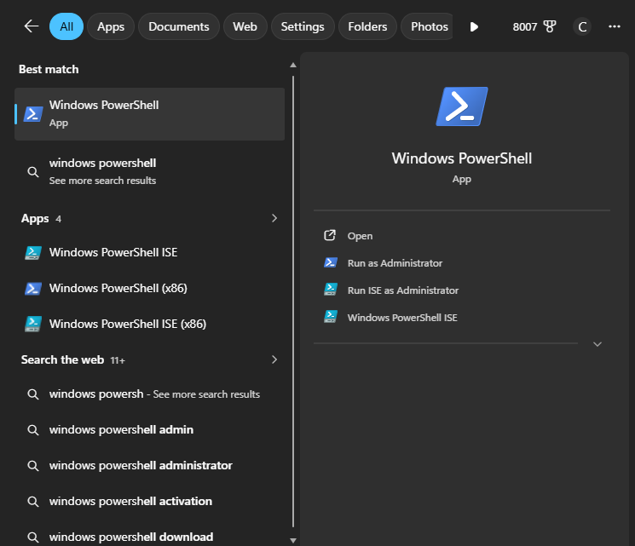

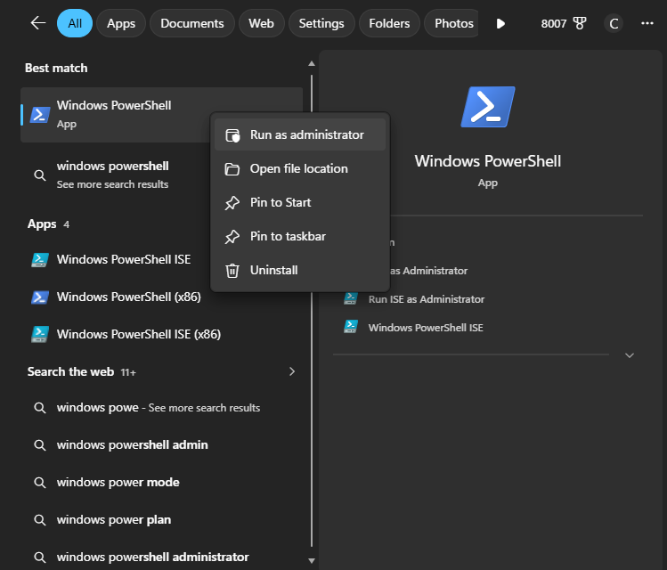

Step 2 : wsl install
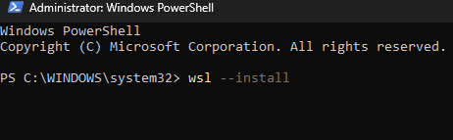
Step 3: Restart Your Computer
Step 4: Complete Ubuntu Setup
Step 5: Create a Password
Step 6: Update Ubuntu
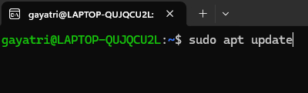
Step 7: Install GCC (C Compiler)
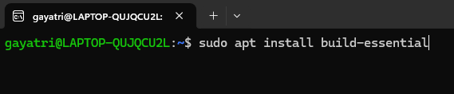
Step 8: Verify the Installation
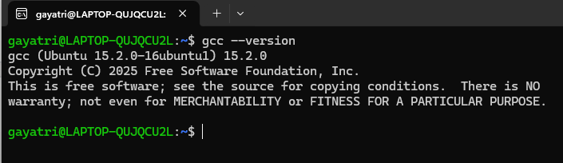
Step 9: Create Your C Program
Step 10: Compile the Program
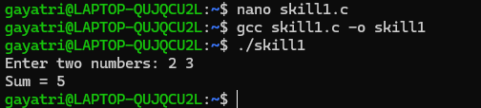
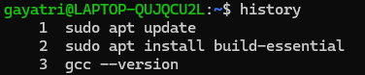
B.
Output:
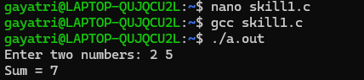

Task - 2:
